LECTURE SYLLABUS
(General medicine)

Pathophysiology of the muscle

Skeletal muscle
Type I fibers = slow, red
Type II fibers = fast, white

Muscle contraction
Myosin, actin, troponin
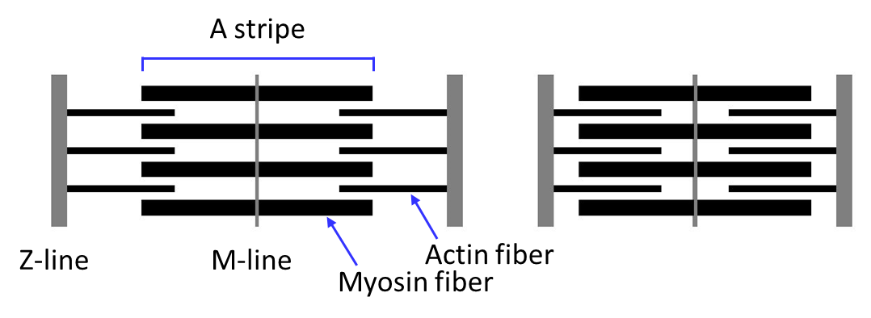

Myoglobin – oxygen reserve

Muscle function control
Central motoneuron → peripheral motoneuron = α-motoneuron (motor nuclei of the cranial nerves, ventral muscle horns) → neuromuscular plate (cholinergic synapse, nicotinic receptor) → muscle fiber

Muscle spindle

Motor unit = group of muscle fibers innervated by one peripheral motoneuron
Fibers in the motor unit are activated simultaneously.

Importance of muscle innervation:
- Contraction control
- Muscle tone control
- Trophic effect
Denervation hypersensitivity → fibrillations

The role of calcium in muscle contraction
- neuromuscular irritability
- induction of muscle contaction

Ryanodine receptor
– calcium channel - Ca²⁺ flow from the sarcoplasmic reticulum into the sarcoplasm
– gating by increase of Ca2+ level in the sarcoplasm or voltage-gated

Tetanic cramps – due to ↓ extracellular Ca²⁺ level (alkalosis, primary hypoparathyroidisms)
Rigor mortis – ATP depletion → inability to release actin - myosin interaction, disappears after 15-25 h due to autolysis of muscle proteins

Muscle energetics and fatigue
ADP + creatine phosphate → ATP + creatine (creatine kinase in the mitochondria)

Muscle activity
→ intracellular acidosis, reduction of glycogen, accumulation of P, synaptic fatigue (lack of neurotransmitter in synaptic terminals) → fatigue, muscle pain

Electromyography
= registration of electric potentials from the skeletal muscles
= electrophysiological method of examination of peripheral nerves (peripheral motoneuron, primary sensitive neuron, pre- and postganglionic autonomic neurons), neuromuscular transmission and skeletal muscles
Diagnosis of subclinical lesions, differential diagnosis

Diseases and disorders of skeletal muscles
Manifestations:
- Disorders of movements (- as well as +):
Fibrillations and fasciculations
- Changes of muscle tone
- Changes of muscle volume
- Muscle pain = myalgia
- Release of substances form the muscle
- Hyperthermia

Disorders of function of skeletal muscles
- movements of the extremities
- postural motorics
- oculomotor, eyelids
- articulation
- swallowing
- voluntary control of sphincters
- breathing!!! – ventilation disorders → type II (global) respiratory insufficiency

Myopathic syndrome
= muscle weakness, ↓ muscle tone, trophic changes
- muscle proteins in the serum

Myotonic syndromes
= ↑ muscle tone, persisting muscle contraction and delayed relaxation
- at voluntary contraction (action myotonia) or as a response to mechanic irritation (mechanic myotonia)

Myotonia congenita
Dystrophic myotonia

Muscle atrophy
= regressive change of the muscle, reduction of muscle mass
Mostly simple atrophy = reduction of muscle fibers size
Numeric atrophy only in severe cases = reduction of muscle fiber number

Causes of atrophy
- Inactivity (long lasting immobilization, palsy)
- Ageing
- Innervation disorders (peripheral motoneuron affection)
- Muscle dystrophy
- Myopathy
- Corticosteroids (Cushing‘s syndrome)
- Ischemia
- Catabolic states, cachexia

Muscle hypertrophy
= increase of muscle mass by enlargement of muscle fibers

Myostatin – produced by muscle cells, inhibition of muscle growth

Causes
- Long lasting adaptation to activity (exercise)
- Effect of anabolics (androgens)
- Lack of myostatin – due to a mutation (semidominant)
Pseudohypertrophy = accumulation of connective fibrous or fat in the muscle

Muscle hypertrophy = enlargement of fiber diameter
Inborn lack of myostatin leads to extreme hypertrophy of the muscles.
Causes:
- Long lasting adaptation to activity (exercise)
- Effect of anabolics (androgens)
- Deficit or absence of myostatin – due to a mutation (semidominant) → extreme muscle hypertrophy

Pseudohypertrophy – accumulation of connective fibrous or fat in the muscle

Abnormal muscle contractions
Cramps
Spasms
Contractures
- physiological
- pathological

Myopathies
= muscle disease with primary affection of the muscle
→ myopathic syndrome

Endocrine myopathies (hyperthyroidism, hypothyroidism, steroid myopathy, acromegaly)
Metabolic myopathies (glykogenoses, lipidoses)
Toxic myopathies
Mitochondrial myopathies

Muscular dystrophias
=progressive degenerations of muscle fibers

Duchenne muscular dystrophy
Mutation of the gene for dystrophin (nonsense, frameshift mutation)
Recessive X-linked heredity → boys
Complete missing of dystrophin

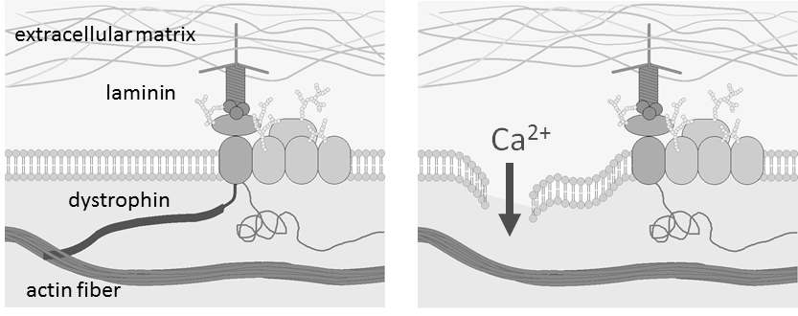

Becker muscular dystrophia
Mutation of the dystrophin encoding gene (missense mutation)
Recessive X-linked heredity → boys
Moderate, but high variability of phenotype severity

Myositis
= muscle inflammation

Rhabdomyolysis
= muscle fiber destruction
→ release of myocyte content (myoglobin, K⁺…) into the extracellular space → blood
→ acute renal failure, hyperkaliemia, DIC
Causes:
- Enzymopathies disturbing muscle metabolism
- Mitochondrial disorders
- Malignant hyperthermia, hyperthermia in general
- Muscle diseases (myopathies)
- Direct muscle injury – crush syndrome, burns, frostbite, el. current
- Muscle ischemia
- Extreme muscle activity (including cramps)
- Hypokalemia, hypophosphatemia
- Myositis, infections (legionella, influenza)
- Diabetic coma
- Toxins – alcohol, snake toxins, CO, cocaine, medicaments (statins, fibrates)
Consequences: Acute renal failure, hyperkaliemia, DIC

Compartment syndrome
= consequence of increased pressure in a limited space
Causes: edema, bleeding, tight bandage, injury, inflammation, vein obstruction, ischemia, burns…

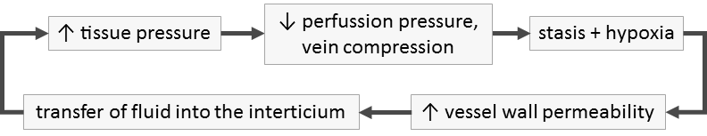

Malignant hyperthermia
= rapid, paroxysmal, life threatening increase of body temperature induced by depolarizing myorelaxants and some anesthetics
Cause: mutation of ryanodine receptor encoding gene, autosomal dominant

Neuromuscular transmission disorders

Muscle tone disorders

