LECTURE SYLLABUS
(General medicine)

Pathophysiology of the endocrine system

Endocrine glands
Hormones
Inactivation/elimination of hormones

Effects of hormones
- Organization
- Activation

Regulation in the endocrine system
Nerve regulation
Simple or complex negative feedback (oscillations)
Positive feedback – e.g. oxytocin during delivery
Regulation with another hormone

Physiological regulatory mechanisms can play a role in pathogenesis of some diseases.

Causes of endocrine diseases
Developmental abnormalities
Mutations in genes for peptide hormones, enzymes necessary for hormone synthesis or for receptors
Injuries
Inflammation
Tumours
Vascular disorders
Iatrogenic (surgery, hormone administration
Disorders of gland regulation
Trophic changes (consequence of long-term change of regulation)

Classification of endocrine disorders
Primary
Secondary
Tertiary

Functional changes
Eufunction
Hyperfunction
Hypofunction
Dysfunction (combination of hyper- and hypofunction of several hormones)

Mechanism of functional changes
Change of synthesis, release or distribution of the hormone
Disorder of degradation or excretion of the hormone
Exogenous origin of the hormone
Ectopic secretion of the hormone
Change of sensitivity of target tissue

Common manifestations of endocrinopathies
metabolic disorders
growth and development abnormalities
changes of body weight
deterioration sexual functions
mental changes
skin symptoms
drop of physical fitness, fatigue
trophic changes

Neurosecretion
= production of hormones by neurons

Hypothalamus – hypophysis system

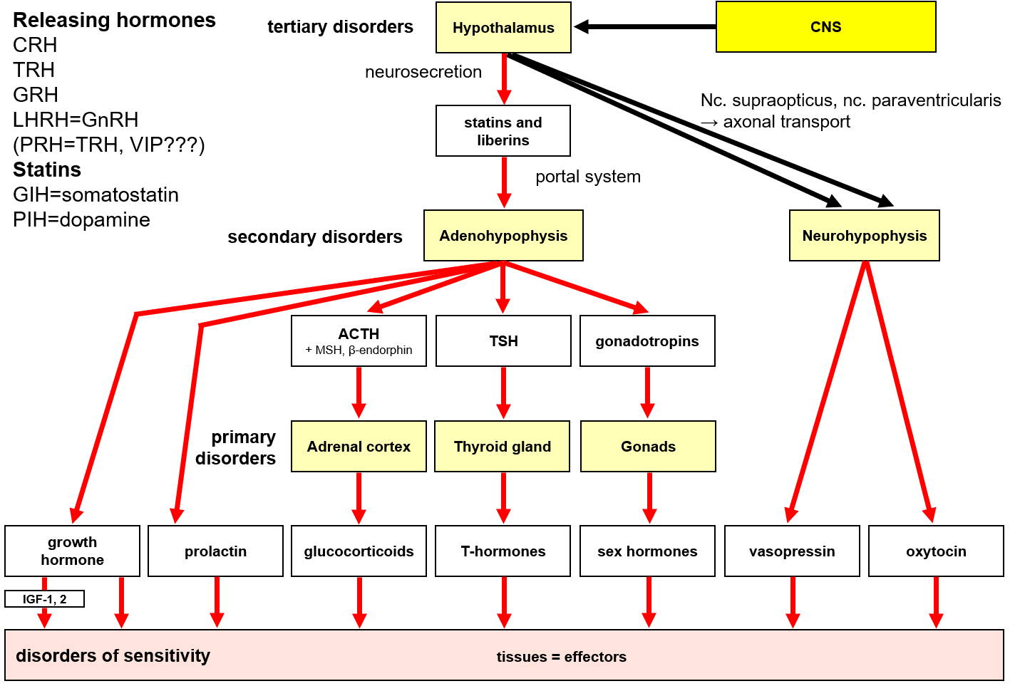

Hypothalamus - neurohypophysis
Synthesis of hormones in the nc. supraopticus and nc. paraventricularis of the hypothalamus: oxytocin, vasopressin
Axonal transport into the neurohypophysis

Vasopressin (ADH)
Central diabetes insipidus
Renal diabetes insipidus
Syndrome of inappropriate secretion of ADH (SIADH, Schwartz-Bartter sy)

Hypothalamus - adenohypophysis

Growth hormone
Lack of GH
– during growth period → nanism

Resistance to GH = Laron's nanism (normal or ↑ GH)

Excess of GH
1. In children → gigantism
2. In the adulthood → acromegaly

Prolactin
↑ of prolactin → galactorrhea-amenorrhea syndrome

Thyroid gland – T-hormones
Hyperthyroidism
Hypothyroidism
- in childern
- in adults
Diseases without thyroid gland function changes = euthyroidism

Goiter
Antithyroidal substances
Thyroid gland nodes
Euthyroid sick syndrome

Hormones regulating calcium metabolism
Hypocalcemia, hypercalcemia

Parathormone
Calcitonin
Vitamin D

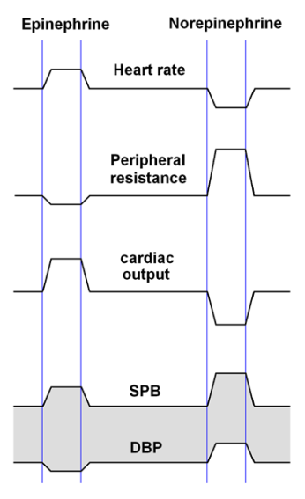
Adrenal gland

Adrenal medulla

Adrenal cortex
Glucocorticoids
Mineralocorticoids
Androgens

Cushing’s syndrome
Addison’s disease
Conn’s syndrome

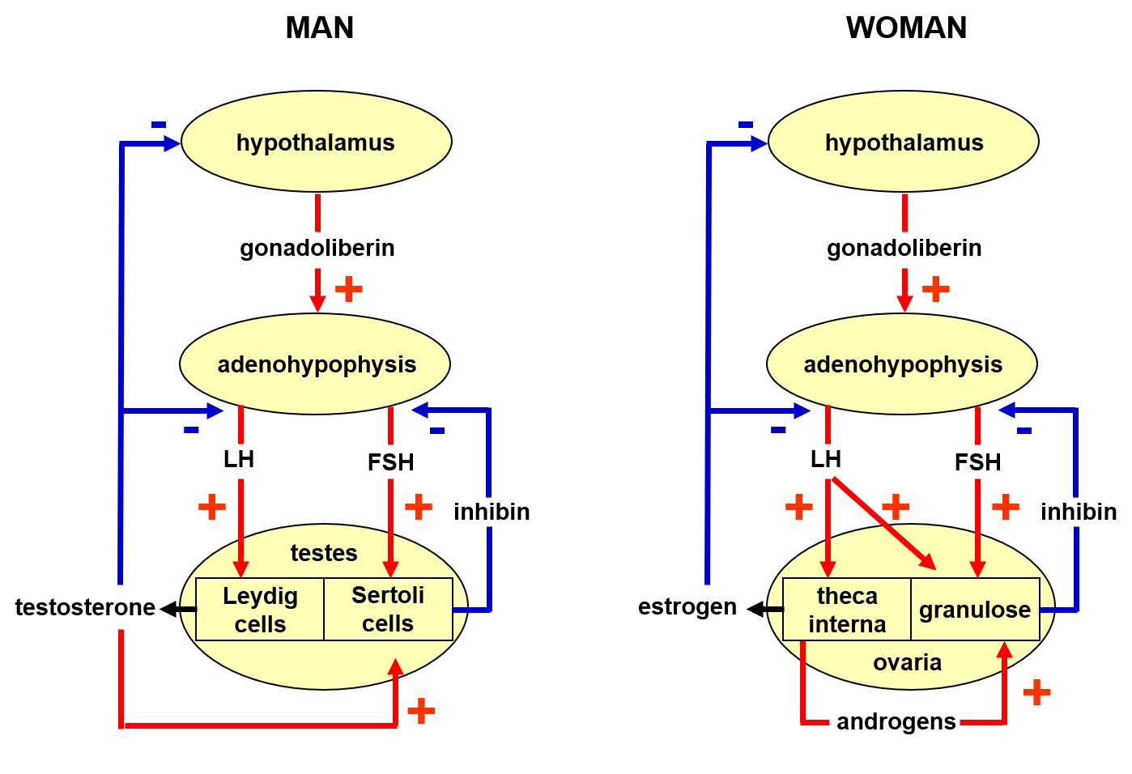
Sex hormones

Menstruation disorders

Pubertas praecox
- preliminary release of gonadotropins, mostly due to hypothalamic disorder
- imitates normal puberty

Pseudopubertas praecox
- preliminary development of secondary sex features without gametogenesis due to the effect of androgens in boys and estrogen in girls

Delayed or missing puberty

Disorders of sexual differentiation
- Hermaphroditism
- Pseudohermaphroditism

Chromosomal aberrations of the gonosomes

Insufficient activity of sex hormones
- hypogonadotropic hypogonadism
- hypergonadotropic hypogonadism

Excessive secretion/effectivity of sex hormones

Hormones regulating glycemia
Insulin
Glucagon
Glucocorticoids
Growth hormone
Epinephrine, norepinephrine
T-hormones

Other hormones
VIP
Gastrin
Somatostatin
Melatonin
Erythropoietin
Natriuretic factors

