LECTURE SYLLABUS
(General medicine, dental medicine)

Pain

= subjective unpleasant sensation mediated by the nervous system and related to real or potential tissue injury

Basic terms
Allodynia = pain caused by a stimulus, which normally does not cause pain.
Analgesia = absence of pain during stimulation which normally causes pain.
Anesthesia = insensitivity to all types of stimuli (all modalities including pain) in a body area or whole body.
Anesthesia dolorosa = pain in insensitive area.
Causalgia = syndrome of permanent pain, allodynia and hyperpathy after traumatic nerve injury.
Central pain = pain caused by primary lesion or dysfunction of the CNS.
Dysesthesia = unpleasant abnormal spontaneous or induced sensation. Always unpleasant (X paresthesia).
Hyperalgesia = increased response to a stimulus, which normally causes pain (increased sensitivity to a suprathreshold stimulus).
Hyperesthesia = increased sensitivity to stimulation (usually tactile).
Hyperpathy = increased sensitive threshold for tactile, nociceptive and thermal stimuli, but if the threshold is exceeded, the stimulus is felt as painful. It leads to excessive response to non-painful or moderate painful stimuli.
Hypoesthesia = decreased sensitivity to stimulation.
Hypoalgesia = decreased response to a stimulus, which normally causes pain.
Neuralgia = pain in distribution zone of the nerve.
Neurogenic pain = pain caused by primary affection, dysfunction or transitory disorder in the peripheral neural system or CNS.
Neuropathic pain = pain caused by primary affection or dysfunction of the neural system – usually used for long lasting disorders and peripheral neural system affections.
Neuropathy = affection of the nerve function or pathological change of the nerve (mononeuropathy = affection of one nerve, polyneuropathy = affection of several nerves).
Nociceptive pain = physiological response to stimulation of nociceptors, long-term stimulation can induce sensitization, but the function of the nervous system is still correct.
Paresthesia = abnormal perception, spontaneous or evoked (not painful – tingling etc.)

Components of pain
Sensory and discriminative
Affection and motivation
Cognition and evaluation
Response

Processes of nociception

Pain transduction
Nociceptors
- high-threshold mechanoreceptors (Aδ)
- polymodal receptors (C)
- fibres (C) activated only after sensitization

Nociceptive stimuli

Mechanisms of transduction: TRPV1 H⁺-activated channels, purinergic receptors, mechanically activated channels

Pain transmission
Nociceptive pathway
Neuron 1: peripheral nerve, neuron of the ggl. spinale, cranial nerve ggl.
Neuron 2: - projection neuron of the dorsal spinal horn
- Nc. tractus spinalis n. V. – subnucleus caudalis
- local spinal interneurons - inhibitory and excitatory
Neuron 3: - thalamus and its ascending connections

Scheme of the nociceptive pathway in the dorsal spinal columns:
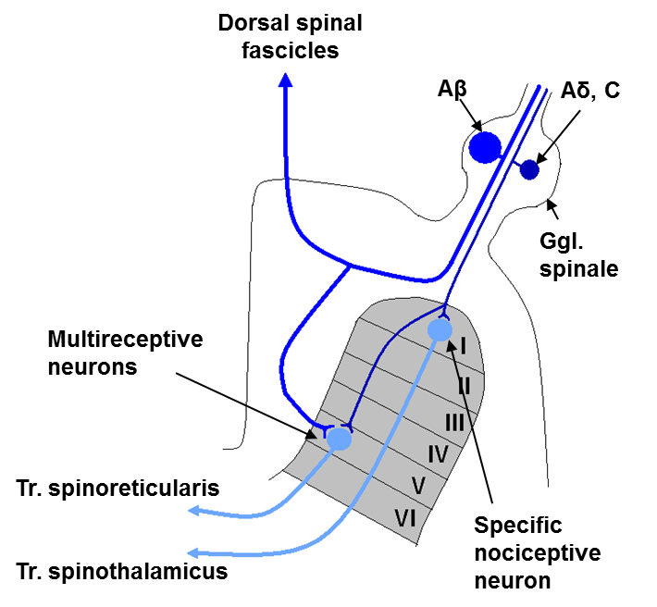

Simplified scheme of the nociceptive pathway on the CNS level
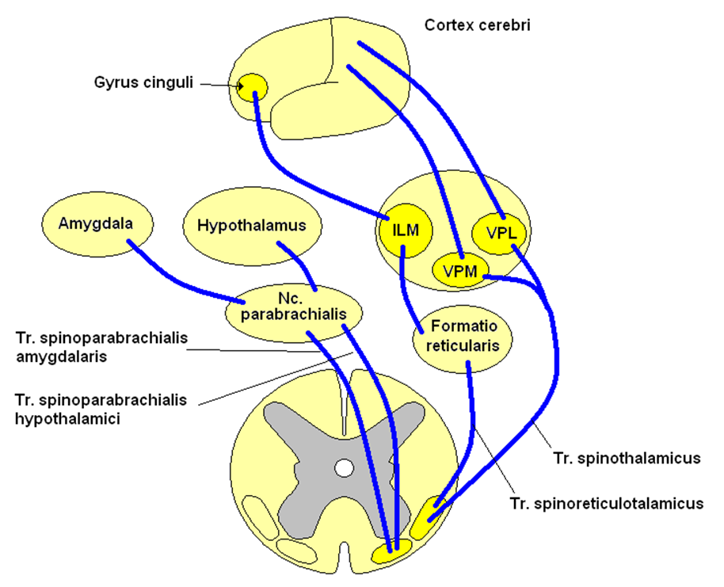

Pain modulation
Peripheral sensitization
- autosensitization
- heterosensitization
- Substance P
- Prostaglandins

Central sensitization
- Modulation of signal transmission on the level of the posterior spinal horns
- Postreceptor mechanisms of modulation on the spinal cord level (prostaglandins, NO)

Gate-control theory (Melzack and Wall, 1965) – rejected by further experiments!

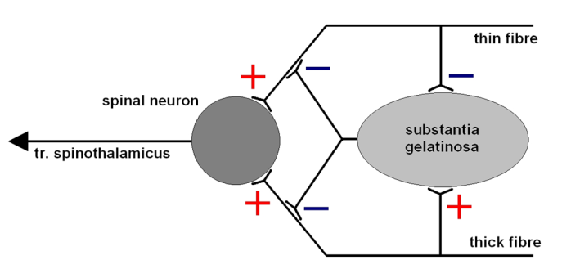

Stress analgesia
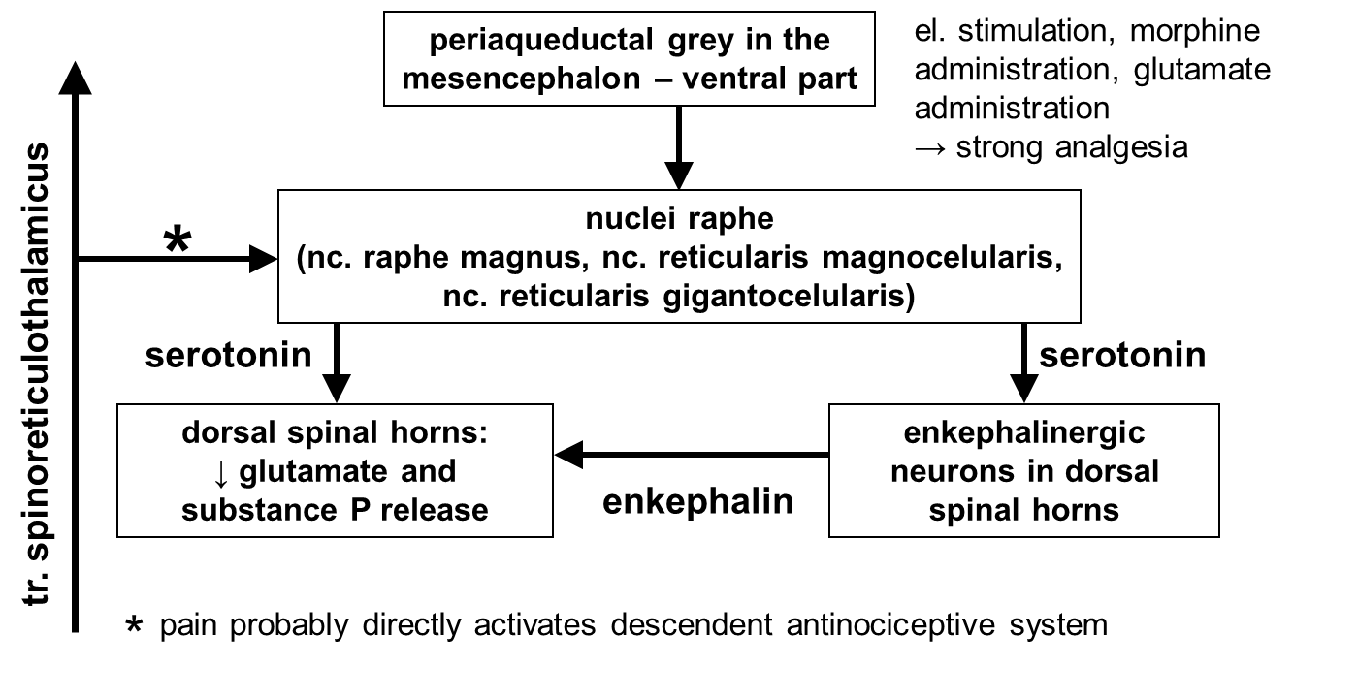
- opioid
receptors: μ, κ, σ, δ, ε

- nonopioid (glutamate, serotonin, noradrenaline, substance P, histamine, canabinoids, estrogens)

Pain types
Duration
- Acute
- Chronic
- malignant
- non-malignant

Cause
- Somatogenic - nociceptive
- neuropathic, neurogenic
- Psychogenic
– without somatic affection!

Localization
- Superficial somatic
- Deep somatic
- Parietal (pseudovisceral)
- Visceral

Referred pain
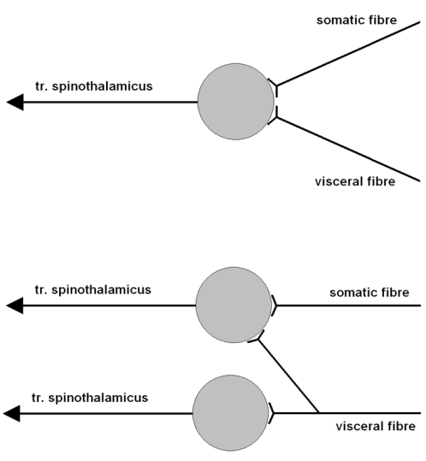
- Theory of convergence

- Theory of facilitation

Disorders of pain perception

Syringomyelic dissociation of sensation (affection of pain and thermic sensation but not tactile and proprioceptive sensation)
- causes: syringomyelia, tumour, injury, haemorrhage
Syringomyelia = cavities filled with cerebrospinal fluid, various causes (including idiopathic cases) and various theories explaining cavity formation mechanisms. Often related to Chiari malformation = dislocation of the cerebellum and oblongata + other potentiall changes of the cerebellum and/or spinal cord (4 types)

Transversal spinal lesion

Brown-Séquard spinal hemisyndrome
- Loss of thermal and algic sensation on the contralateral side
- Loss of proprioception and tactile sensation and central palsy (at the level of the lesion peripheral palsy) on the side of the lesion

Congenital and hereditary insensitivity to pain syndromes
- Disturbances of development of the nociceptive system neurons

Neuropathy

Neuropathic pain
= initiated or caused by a primary lesion or dysfunction of the neural system
- does not require stimulation of the nociceptors (however it can enhance neuropathic pain)

Peripheral neuropathic pain
- abnormal peripheral sensitization
- generation of ectopic impulses in nociceptive fibers (irritated, injured, regenerated axon...)
- ephaptic contacts (cross-talk)
- multiplication and functional change of ion channels (Na⁺)
- local dysfunction of sympathetic system → stimulation of nociceptive pathway by cathecholamines
- enlargement of receptive fields of dorsal spinal horn neurons
- inhibition of descendent inhibitory mechanisms
Examples: trigenimal neuralgia, glossopharyngeal neuralgia, neuralgia ganglii geniculi, carpal channel syndrome, post-operative neuralgia, post-traumatic neuralgia, post-herpetic neuralgia, post-irradiation neuropathy

Central neuropathic pain
- irritation of the nociceptive tract on the CNS level (inflammation, tumour, compression...)
- lesion on the lower level increases sensitivity of the higher level structures → hyperreactivity in unaffected CNS structures after loss of the normal patterns of afferentation
Examples: Traumatic spinal lesions, multiple sclerosis, central neurogenic post-ictal pain (e.g. thalamic pain), post-irradiation myelopathy, syringomyelia

Painful syndromes and states
Phantom pain
= pain localized in amputated part of the body
- persistence of original somatotopic organisation of the pathways and cortical projection
- irritation of the stump of the amputated nerve + ↓ threshold of sensitivity of regenerating nerve fibres

Thalamic pain
- Irritation of thalamic nuclei involved in nociceptive pathway
- No response to analgetics

Radicular pain
- Irritation of the dorsal spinal root (e.g. due to affection of the vertebral column)
- Pain in appropriate area radicularis

Pain treatment

Pharmacological
Analgetics
- NSAID (Non-Steroid Anti-inflammatory Drugs) – COX inhibitors
- paracetamol (children)
- opioids – tolerance, dependence
-ketamine - non-competitive NMDA receptor blocker
Anesthetics
Anticonvulsives
Corticoids
Capsaicin
Antidepressants

Surgical

Neuromodulation
stimulation - transcutaneous electric nerve stimulation (TENS)
- of the dorsal spinal fascicles
- of the dorsal spinal roots
- of the thalamus
- of the periaqueductal grey
- of the motor cortex

Psychological

