LECTURE SYLLABUS
(General medicine, dental medicine)

Pathophysiology of immunity

I. Introduction

Definition of immunity – immunity - interdisciplinary issue; importance of immunity in pathogenesis; immunity – main part of the organism reactivity

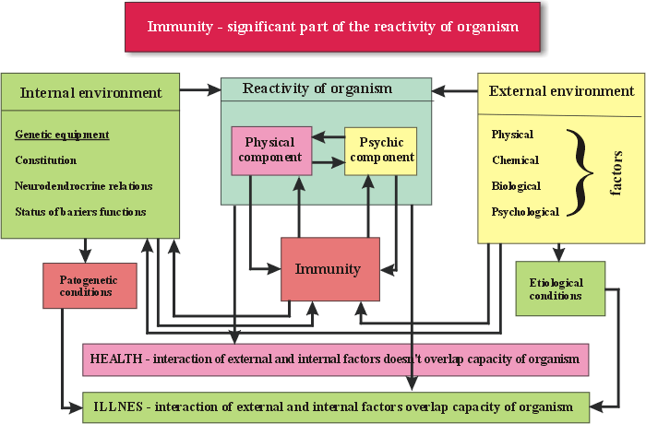

Immunity disorders in reaction to individual systems of the body

Imunity and nervous system; neuropeptides, neurohormones, neurotransmitters of the immune
system; psychoneuroendocrino-immunology

Joint mediators of the neuroendocrine and immune system

Pituitary hormones Neuropeptides
Adrenocorticotropic hormone (ACTH) (Met) enkephalin
Endorphins Arginine vasopressin (AVP)
Thyroid-stimulating hormone (TSH), Oxytocin
Chorionic gonadotrophin (HCG) Neuropeptide Y
Luteinizing hormone (LH) Vasoactive intestinal peptide (VIP)
Follicle-stimulating hormone (FSH), Somatostatin (SST)
Prolactin (PRL) Insulin-like growth factor 1 (IGF - 1)
Somatotropic hormone (STH)

Hypothalamic releasing factors
Corticotropin-releasing hormone (CRH)
Somatotropin releasing hormone (SRH)
Luteinizing hormone releasing hormone (LH-RH)

Some types of glia and neurons are able to form cytokines (interleukins: IL 1, 6, 10; interferons IFN α, β, γ, TNF-α (Tumor necrosis factor), TGF β (transforming growth factor); GM-CSF (Granulocyte macrophage colony stimulating factor), MCP-1 (Monocyte chemoattractant protein); MIP-1 (Microphage inflammatory protein)

Gaseous mediators
Nitric oxide (NO) gas neuro immuno-modulator and general biological messenger acting on the nervous (synaptic transmission, cognition), immune and vascular system
Hydrogen sulphide (H2S) gas in a neurotransmitter significant induction of hippocampal LTP, nociception, in the periphery is involved in relaxation of smooth-muscle
Carbon monoxide (CO) gas is a general neuromodulator acting both in the peripheral and central NS (synaptic plasticity, brain stress control)

All these gases are involved in the regulation of the HPA stress axis in the hypothalamus

II. The main components of the immune system
- Stem cells, support system, phagocyte cells, central and peripheral lymphoid organs

III. Division of immunity
– Innate (congenital) immunity, acquired (secondary) immunity

IV. Innate immunity

Phagocytosis
- Characteristic, macrophages, microphages, opsonins
- Innate disorders of phagocytosis acquired disorders of phagocytosis

Complement system
- Characteristic, production of complement proteins
- Innate disorders of complement activity
- Acquired changes of complement activity, increased complement activity in relation to some pathological states

Interpheron system
- Characteristics
- Pathological states due to secondary reduction and increased activity of interpheron system

NK – cells activity
Barrier functions of the skin and mucous membrane

IV. Inflammation
- Definition, characteristics and cardinal signs in relation to changes of circulation

- Stages of inflammation, mediators of inflammation

- General systemic aspects and symptoms of inflammation

V. Acquired immunity

Humoral immunity (B cell immunity)

Cell mediated immunity (T cell immunity)

Specificity of T lymphocytes and antibodies, lymphocyte clones,

VI. Characteristics of immunity reaction

Centripetal

Central

Centrifugal

VII. Division of immunopathological states

1. States of the immunity insufficiency

- Primary (innate), reticular dysgenesis, thymic hypoplasia (Di GEORGE´S sy) syndromes of combined immunodeficiency disorders (SCID)

- Secondary (acquired): General causes of acquired immunity disorders

AIDS (Acquired Immunodeficiency Syndrome)

2. Pathological states and diseases caused by humoral and cellular mechanisms

a) Reagine – type hypersensitivity (early hypersensitivity) ATOPY, ANAPHYLAXIS (ALLERGY), ANAPHYLACTIC SHOCK.

- Pathological states and diseases caused by antibodies against cellular signs and receptors.
- Diseases caused by immunity complexes.

- Pathological states caused by cellular (late) hypersensitivity.

- Diseases characterized by the creation of granulomas.

a), b), c) – 1.- 3. type of early reaction
d) 4. type of late reaction (according to Coombs and Gell)

3. Autoimmune diseases (pathophysiology; examples; important factors)

4. Lymphoproliferative diseases

VIII. Special immunopathological states

Transplantation (autogenous, isogenous, allogenous, xenogenous)

Cell transplantation, tissue transplantation, organs transplantation, immunosuppression

