LECTURE SYLLABUS
(General medicine)

Pathophysiology of the nervous system

Introduction

Functional and structural characteristics of the nervous system activity in health and disease (neuromediators, receptors)

- Synthesis of the mediator in the presynaptic formation
- Storage of the mediator in the presynaptic formation and its delivery to the synaptic cleft
- Interaction with the postsynaptic membrane receptor
- Removing the mediator from the synaptic cleft
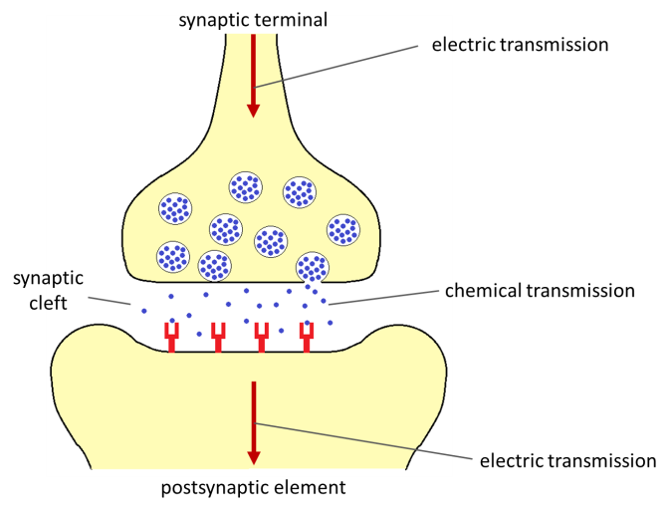
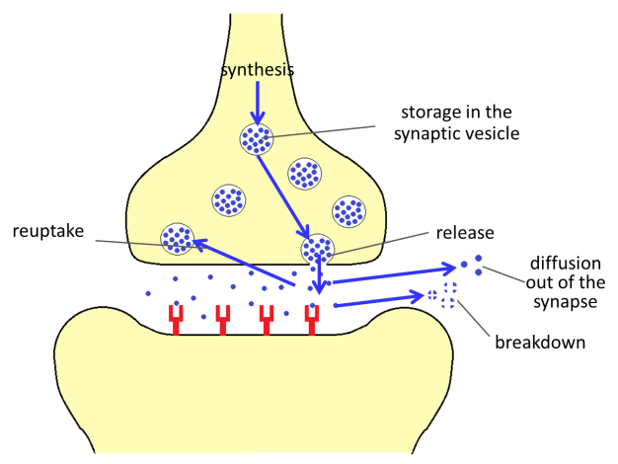

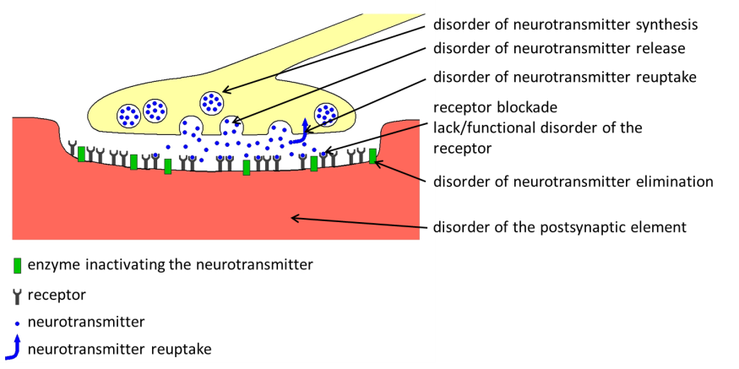

Etiological factors affecting the nervous system

General features (role of the reactivity of the organism)
Relationship of the external and internal factors

General features of pathogenetical mechanisms of nervous dysfunctions

Brain edema – core, consequences (complication and pathogenetical factor of many pathological states)

Mitochondrial dysfunction
Basis of mitochondrial functions
- disturbances evoked by mutations mtDNA and nDNA in genes coding mitochondrial functions (changes of mitochondrial genome, evoked defects of mtDNA)

- consequences of mtDNA defects

- mitochondrial disturbances evoked by external factors

Neurochemical basis of the pathophysiology of trauma

Excitotoxicity of glutamate (core, possibilities of influencing it and prevention)

Survey of basic neuropathological terms

Irritative or hyperfunctional and extinct or hypofunctional disturbances.

Irritative disorders of the motor system (Jackson´s motor epilepsy, tremor, myoclonia, hyperkinesia…)
Extinct disorders of the motor system (paralyses – central, peripheral, pareses, plegias, ataxia, abasia, astasia)

Irritative disorders of the afferent system (Jackson's sensitive epilepsy, paraesthesia, hyperesthesia, dysaesthesia, causalgia, neuralgia, phantom pain, hyperalgesia, aura - basically pseudohalucinacea - deceptive perception of visual, olfactory or sensory qualities, aura, psychological aura)

Extinction disorders of the afferent systems (hypoaesthesia, anesthesia, thermogenesis, bathyanesthesia, hypocalcaemia, hypacusis, anacusis, amaurosis, hemianopsia, scotomy, hypogeusia, ageusia, hyposmia, anosmia).

Disturbances of the vegetative nervous systém

Concern both the central and peripheral parts of the autonomic nervous system (trophic disorders, blood circulation, vegetative dystonia)

Maintenance and recovery of the NS integrity

Plasticity of the NS
a) redundancy (excess neurons and physiological extinction)
b) alternation (another structure will take over the function of the defunct center)
c) vicarious function (the lost function is partly taken over by another modality eg. visual-hearing
d) diaschisis (temporary removal from function)

Critical developmental periods (brain growth spurt and CNS vulnerability)

Neurotransplantation

Principles, present state of research and practice (examples)

Methods of research and examination of neural functions

Reflex examination, examination of motor functions
Sensory perception examination
Stimulative methods
Macroelectrophysiological recording methods
EEG, ERP (EP)
Microelectrophysiological methods

Unit activity, voltage clamp, patch clamp
Stereotaxis
Depictive examination methods
Thermography, sonography, X-ray examination, computer tomography, scintigraphy, magnetic resonance imaging (MRI)
Brain mapping positron emission tomography

Genetically determined diseases of the NS
(Changes in chromosome equipment, inborn disorders of metabolism with impacts on nerve function)
Diseases with preferential CNS affection
Multi-organ affections, including NS
Congenital metabolic disorders with CNS impact

Diseases with predominance of external factors
Physical factors, nutrition, intoxication, neuroinfection (bacterial, viral, prion)

Diseases with combined and unclear etiology

Neuroimmunological diseases
Tumors
Degenerative diseases
Demyelination with mixed etiology
Subacute combined spinal degeneration Sclerosis multiplex, epilepsy
Parkinson´s disease, schizophrenia
Alzheimer ´s disease

Pathophysiology of the spinal cord

Spinal syndromes
Spinal transverse interruption syndrome, spinal shock
Spinal hemisyndrome /Brown-Sequard sy/
Tabic dissociation of sensation (dorsal spinal columns sy)
Syndrome of the lateral spinal columns
Syringomyelic dissociation of sensation (grey commissure sy)

Disorders of the spinal vegetative systems
Syndromes from cervical sympathetic disorders (Claude-Bernard-Horner, ganglia stellati)
Disorders of urination and defecation

Pathophysiology of the brain stem
Reticular formation, decerebration rigidity
Sy "cerveau isolé"
Sy "encéphale isolé"
Bulbar paralysis, pseudobulbar syndrome, alternating syndromes

Pathophysiology of the cerebellum
The role of the cerebellum in motor, cognitive and emotional functions
New conception of the cerebellum
Cerebellar syndromes: extinct (dysfunctional, irritative, cognitive-affective)
Cerebellar ataxia

Pathophysiology of the diencephalon
(thalamus a metathalamus, hypothalamus, epithalamus, subthalamus)
Pf of the thalamus
Thalamic syndromes, thalamic pain
Pf of the hypothalamus
Food and fluid intake, sexual function, hormonal function, thermoregulation, vegetative nervous system control

Pathophysiology of the cerebral hemispheres
Pf of basal ganglia
Hypertonic-hypokinetic sy,
Hypotonic -hyperkinetic sy

Pf of the brain cortex
Pf of the allocortex - the limbic system, (the hippocampus and amygdala)
Pf of the neocortex - primary projection areas, association areas, effector areas (motor, vegetative, suppressor), frontal lobe sy (prefrontal lobotomy), aphasia, alexia, agraphia, apraxia, dyslexia

Behavior and its disorders

Instinctual behavior, motivation, drives (respiratory, hunger, thirst, sexual)
Emotions (feeling affects, fear, joy, rage, mood...), vegetative components, startle, freezing
Highest (cognitive) nervous functions (HNF)

Conditioning (time relationships, appetitive and aversive conditional reflexes),
Excitation, inhibition, induction
Learning and memory (associative, non-associative), short-term (working), intermediate,
Long-term (reference)
HTSIF and integration
Neural typology: Pavlov (Hippocrates), Kretschmer, Friedman and Rosenman.

HNF disorders
Neurosis, psychosis, organic disorders (neural and non-neural origin)

Life rhythms
Circadian rhythm, pacemaker, melatonin
Sleep (REM, non-REM), sleep disorders

Neurohumoral and visceral regulations
Neurovegetative dystonia, psychosomatic diseases

